Week Ending: | DAY: |  |  |  | Subject: Science
Duration: 60mins per lesson |  |  |  |  | Strand: Humans & The Environment
Class: B5 | Class Size: |  |  |  | Sub Strand: Science and Industry
Content Standard:  B5.5.3.1 Recognize the impact of science and technology in society |  |  | Indicator:  B5.5.3.1.1 Identify the raw materials used in some local industries |  |  | Lesson:  1 OF 1
Performance Indicator:  - Learners can identify the raw materials used in some local industries |  |  |  | Core Competencies:  Problem Solving skills; Critical Thinking; Justification of Ideas;
Teaching/ Learning Resources |  | Gari, kenkey, shea butter, cooking oil, blacksmith, basketry
References: Science Curriculum Pg. 31
DAYS | PHASE 1: STARTER | PHASE 2: MAIN | PHASE 3: REFLECTION
 | The teacher brings a bag into the classroom that contains an object that has a connection to the lesson.  Then it is passed around and learners try to determine what is in the bag just by feeling it.  The student who guess right wins, and hence introduce the lesson | 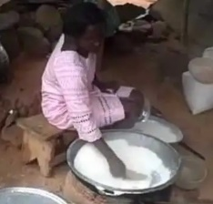  Take learners to a local gari or kenkey production site or show videos of such ventures.  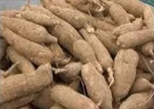  Learners observe critically and identify the raw materials used in the various industries.    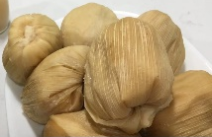  Engage the learners in a matching activity to match some local products with their raw materials. | Ask learners questions to review their understanding of the lesson.  Have learners write 3 facts of the lesson on a sheet of paper and it in their pockets and learn it on their way home.
 | Teacher writes and lets students see the answer on the board, perhaps a picture of object on the board.  The students must come up with questions in which the answer could be the object on the board. | Take learners to a local shea butter or cooking oil production site or show videos of such ventures.  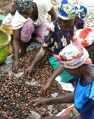  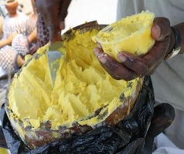  Learners observe critically and identify the raw materials used in the various industries.  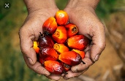  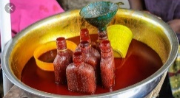  Engage the learners in a matching activity to match some local products with their raw materials. | Ask learners questions to review their understanding of the lesson.  Have learners write 3 facts of the lesson on a sheet of paper and it in their pockets and learn it on their way home.  Next lesson: Identify the raw materials used in some local industries

